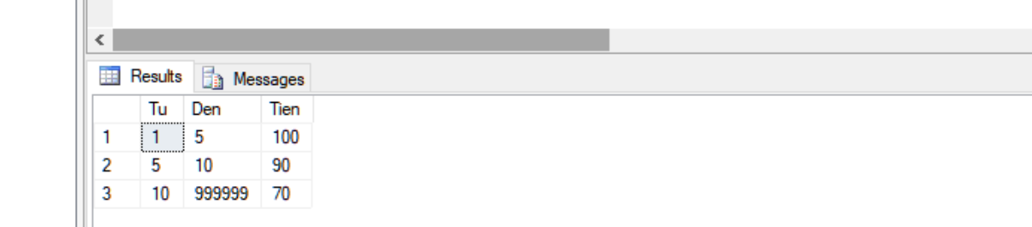
SELECT a.SoLuong as Tu,(case when a.SoLuong=b.SoLuong then 999999 else b.SoLuong end) as Den, a.Tien FROM PRODUCTpRICE a,ProductPrice b
where a.Ma=b.Ma-1 OR a.Ma=(select MAX(ma) from ProductPrice) and b.Ma=(select MAX(ma) from ProductPrice)
order by a.SoLuong

